SPECIAL OFFERS
Brisbane Food Lovers is your one stop shop connecting lovers of food and local business. With a follower base of over 20 000, we are now offering selected businesses the chance to get involved in a special offers program. Exclusive to the Brisbane Food Lovers community, daily promotions are listed. You can opt to feature your promotion, weekly, monthly or once of. This is an ideal way to promote your offerings directly to lovers of food, without the hefty costing associated with traditional promotional channels. FREE LISTINGS FOR A LIMITED TIME!
EXAMPLE
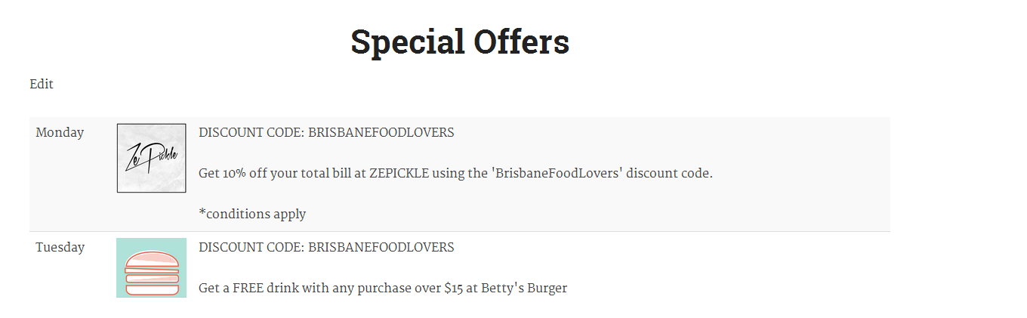
EXAMPLE

Fill out the application form below to have your offer listed.
BUSINESS NAME:

PRIMARY CONTACT:

PHONE NUMBER:

WEBSITE:

INSTAGRAM HANDLE:

EMAIL:

LOCATION:

OFFER:

SELECT THE DATES YOU WOULD LIKE YOUR OFFER TO RUN ON (add your business name in the calendar):
December
Sun |  | Mon |  | Tue |  | Wed |  | Thu |  | Fri |  |  | Sat
 |  |  |  |  |  |  |  |  |  |  |  |  | 1
2 |  | 3 |  | 4 |  | 5 |  | 6 |  | 7 |  |  | 8
9 |  | 10 |  | 11 |  | 12 |  | 13 |  | 14 |  |  | 15
16 |  | 17 |  | 18 |  | 19 |  | 20 |  | 21 |  |  | 22
23 |  | 24 |  | 25 |  | 26 |  | 27 |  | 28 |  |  | 29
30 |  | 31

Thank you for taking the time to fill out the SPECIAL OFFERS form. We shall be in contact with you shortly to confirm. For any further queries, do not hesitate to contact us.
EMAIL: brisbanefoodlovers@gmail.com

